**Ideation Phase**

**Brainstorm & Idea Prioritization**

**For AI&ML Project Work**

|  |  |
| --- | --- |
| Date | 16 JUNE 2025 |
| Team ID | LTVIP2025TMID35419 |
| Project Name | Transfer Learning-Based Classification of Poultry Diseases for Enhanced Health Management |
| Maximum Marks | 4 Marks |

**Brainstorm & Idea Prioritization:**

**Step-1: Team Gathering, Collaboration and Select the Problem Statement**

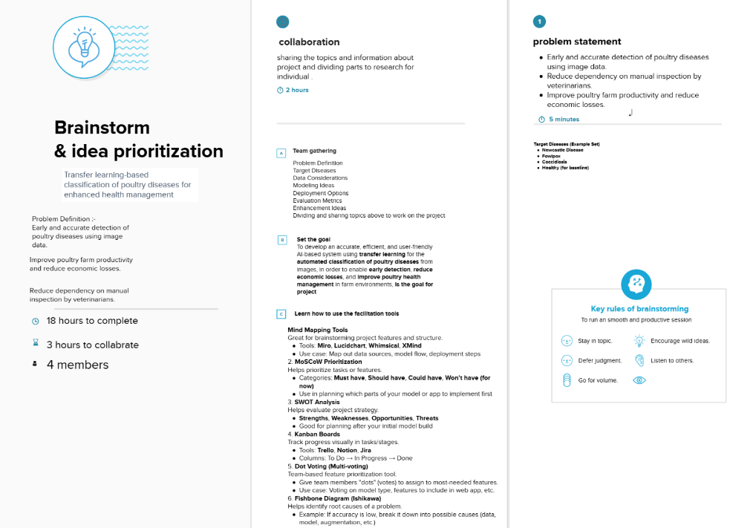

**Step-2: Brainstorm, Idea Listing and Grouping**

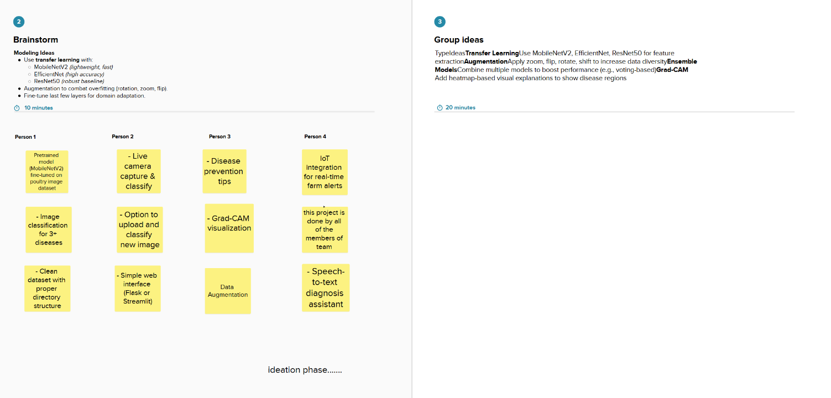

**Step-3: Idea Prioritization**

